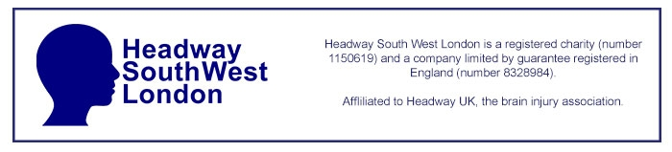

HSWL Emergency Fund Grant Application Form

About the person applying for the emergency fund grant
First name: |  | Last name:
Email address: |  | Phone number:
Address:

Reason for applying for the emergency funding:

Amount required:  (Maximum £500) | £
Please provide a breakdown of how the grant will be spent:

Does the person requiring help have savings of more than £1000? Yes / No

Declaration

I declare that the information provided above is true and accurate and that the person requiring help is in genuine need of emergency funds.

I agree that HSWL may contact me by telephone or email for any additional information and may request to see documentation to prove my identity and/or confirm a history of brain injury.

I understand the information I have provided here will be stored securely in an electronic format for a maximum of 18 months, shall only be used for HSWL emergency fund grant applications and audit purposes, and will not be shared with any other third party.

Print name:
Signature:
Date:

